Testing Document

Contents

Scope 3

Device Requirements 3

Computers 3

Tablets and Mobiles 3

Apple 3

Android 3

Testing Case 3

Responsive Layout 5

Admin Page 6

Desktop 1920x1080 6

Tablet 800 x 1280 Portrait 7

Tablet 1280x800 Landscape 7

Mobile 375x667 Portrait e.g. Iphone 6 8

Mobile 667x375 Landscape e.g. Iphone 6 8

Frequent Search Chart 9

Desktop 1920x1080 9

Tablet 1280x800 Landscape 9

Tablet 1280x800 Portrait 10

Mobile 375x667 Portrait e.g. Iphone 6 11

Mobile 667x375 Landscape e.g. Iphone 6 11

# Scope

CITE Managed Services develops software for a range of clients and from time to time they will utilise external contractors when appropriate. Team D (us) have been employed to implement a Movie Database for Acme Entertainment Pty Ltd.

It is required that the website has a client log in area, admin log in area and has a way to rate movies.

# Device Requirements

## Computers

* Windows 7, Windows 8, Windows 8.1, Windows 10 or later
* An Intel Pentium 4 processor or later that's SSE2 capable
* OS X Yosemite 10.10 or later
* 64-bit Ubuntu 14.04+, Debian 8+, openSUSE 13.3+, or Fedora Linux 24+

## Tablets and Mobiles

### Apple

* iPad, iPhone, and iPod Touch
* iOS 10 or later
* All languages supported by the App Store

### Android

* Chrome is available on phones and tablets running Android 4.4+ (KitKat).

# Testing Case

Testing Case for database searching

|  |  |  |
| --- | --- | --- |
| Case | Description | Screenshot |
| 1 | Admin can login to the admin panel |  |
| 2 | Admin can reset there password |  |
| 3 | Admin can create other admins |  |
| 4 | Client can login |  |
| 5 | Client can signup |  |
| 6 | Client can rate movies |  |

# Responsive Layout

With the responsive layout it won’t necessarily look like the tablet version if the tablet screen is small. If your mobile screen is huge than it will scale around your device screen etc. The database connection will work the same as long as you have an internet connection queries will be sent through.

## Admin Page

### Desktop 1920x1080

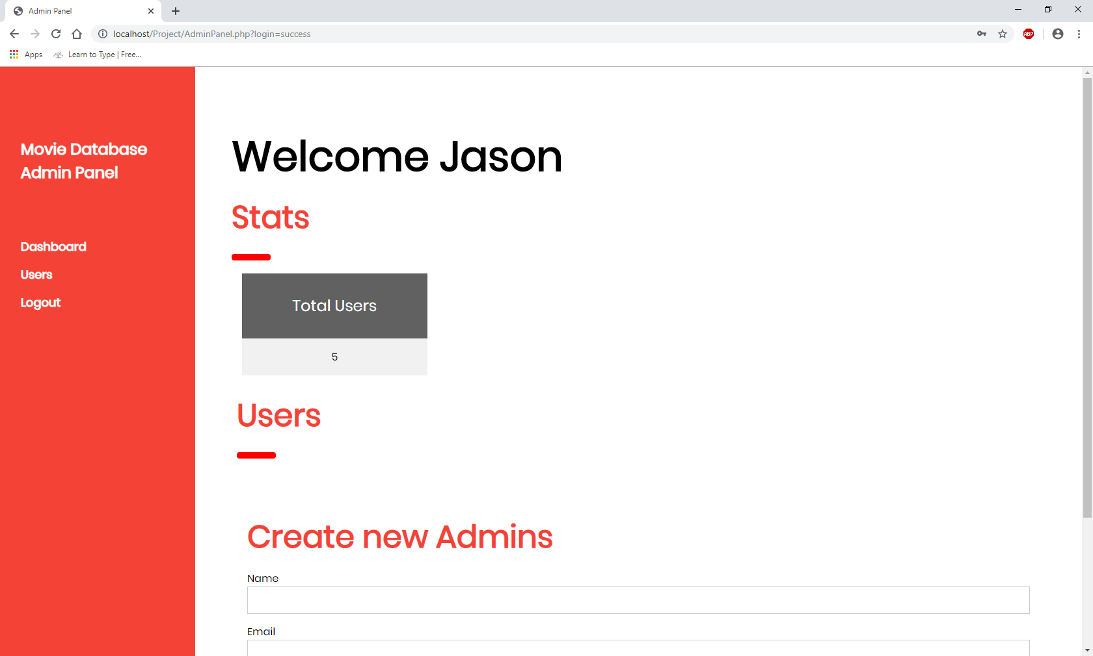

### Tablet 800 x 1280 Portrait

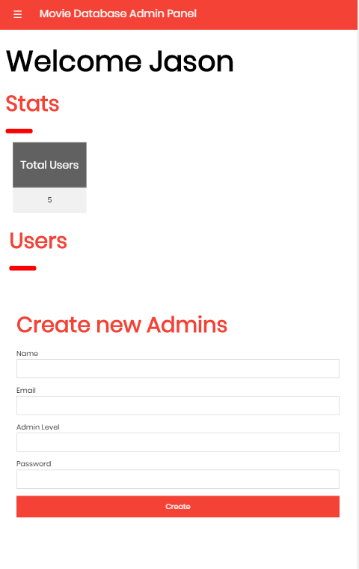

### Tablet 1280x800 Landscape

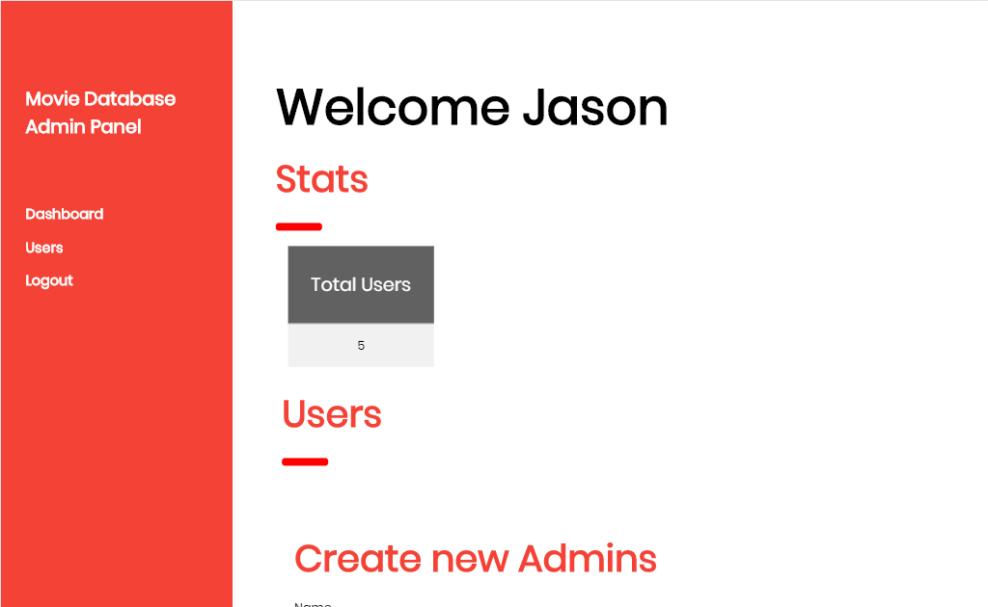

### Mobile 375x667 Portrait e.g. Iphone 6

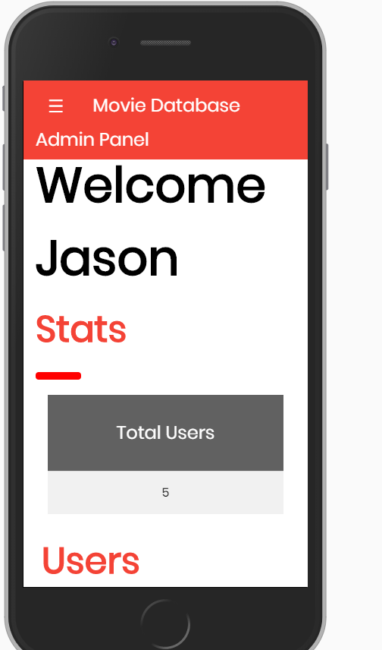

### Mobile 667x375 Landscape e.g. Iphone 6



## Frequent Search Chart

### Desktop 1920x1080

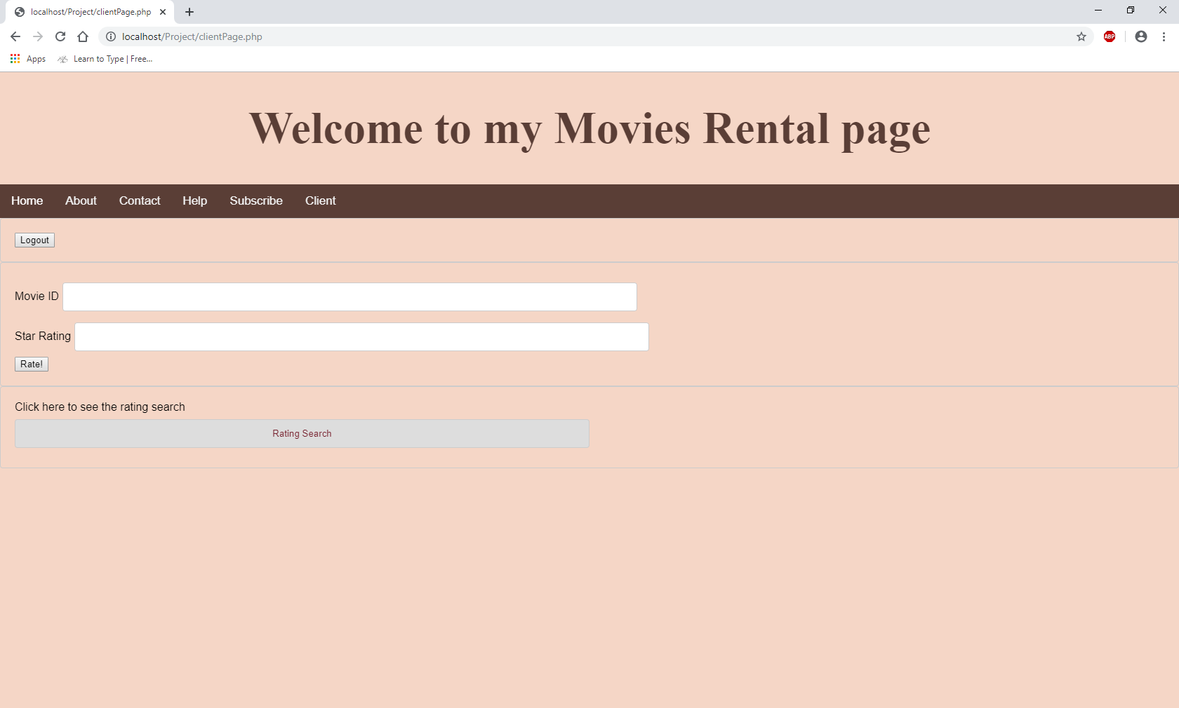

### Tablet 1280x800 Landscape

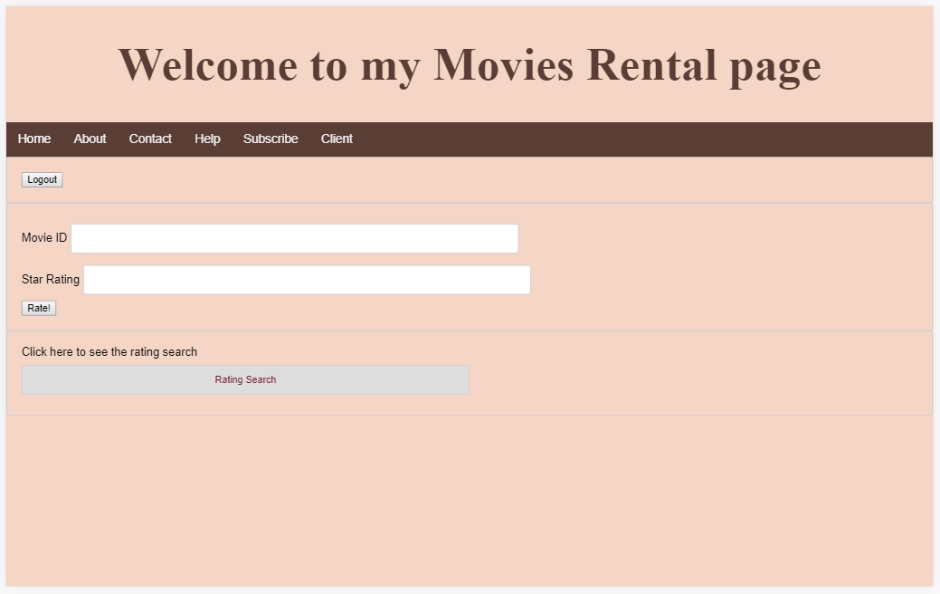

### Tablet 1280x800 Portrait

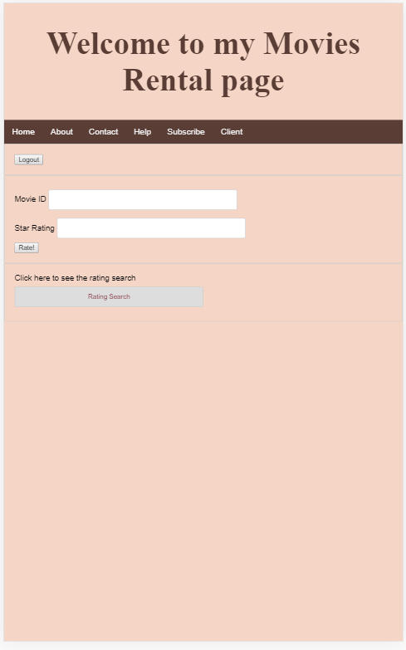

### Mobile 375x667 Portrait e.g. Iphone 6

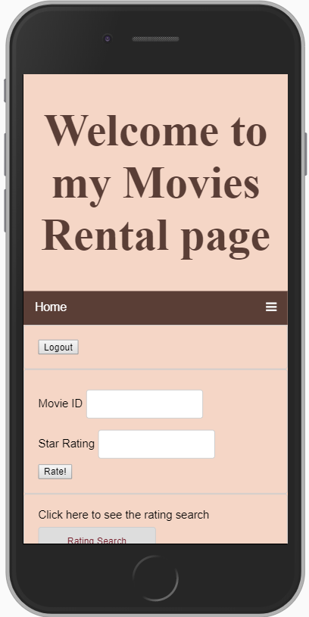

### Mobile 667x375 Landscape e.g. Iphone 6

